Ideation Phase Empathize&Discover

|  |  |
| --- | --- |
| Date | 3 July 2025 |
| TeamID | LTVIP2025TMID60948 |
| ProjectName | MeasuringthePulseofProsperity:AnIndexof  EconomicFreedomAnalysis |
| MaximumMarks | 4 Marks |

# EmpathyMap Canvas:

Anempathymapisasimple,easy-to-digestvisualthatcapturesknowledgeaboutauser’s

behavioursandattitudes.

Itisausefultooltohelpsteamsbetterunderstandtheirusers.

Creating an effective solution requires understanding the true problem and the person who is experiencing it. The exercise of creating the map helps participants consider things from the user’s perspective along with his or her goals and challenges.

# Example:

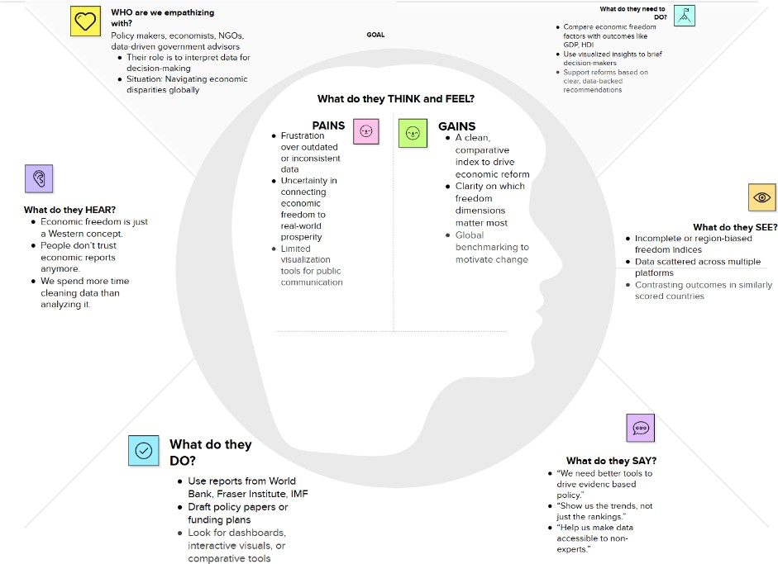

Reference:<https://www.mural.co/templates/empathy-map-canvas>